**Class Assignment – Coordination Chemistry** 03/25/2021

Name: Max Shi

Name:

Name:

Name:

**Questions (20 pts):**

**Q1. Give chemical names for the following:**

**Note: Identify the charge if charge is not given**

1. [Fe(CN)2(CH3CN)4]
   1. Dicyanotris(methyl isocyanide)iron(II)
   2. No charge
2. Rb[AgF4]
   1. Rubidium tetraflouroargentate(I)
   2. No charge
3. [Ir(CO)Cl(PPh3)4] (two isomers)
   1. Carbonylchlorotetrakis(triphenylphosphate)iridium(I)
   2. No charge
4. [Co(N3)(NH3)5]SO4
   1. Pentaammineazidocobalt(III) sulfate
   2. No charge­
5. [Ag(NH3)2][BF4]
   1. Diamminesilver(I) tetrafluoroborate
   2. No charge
6. [Pt(en)Cl2]
   1. Dichloro(ethylenediamine)platinum(II)
   2. No charge
7. [Fe(OH)4]-
   1. Tetrahydroxoferrate(III)
8. [V(C2O3)3]3-
   1. Tris(oxalato)vanadate(III)

**Q2.** Give the structures of these coordination complexes: Label them *cis, trans* and enantiomers.

1. Tris(acetylacetonato)iron(III)
   1. 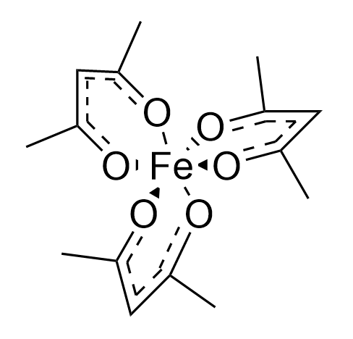
2. Potassium diamminetetrabromocobaltate(III) (both cis and trans isomers)
   1. 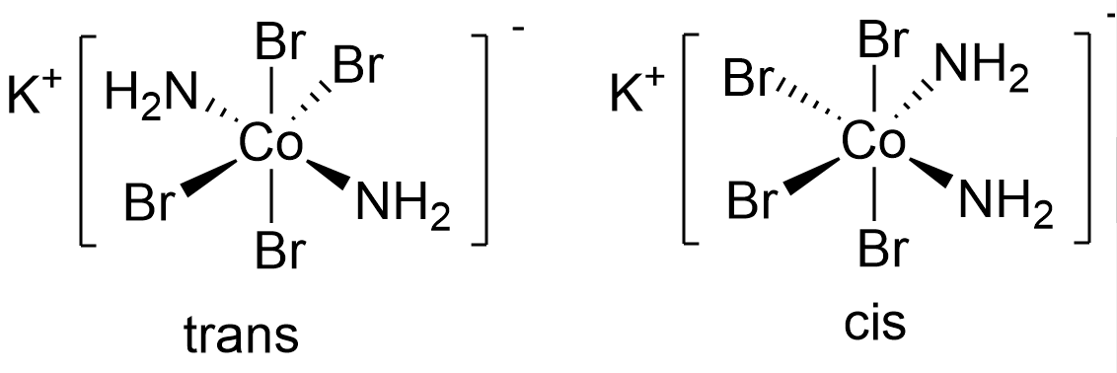
3. Tris(ethylenediamine)copper(II) sulfate
   1. 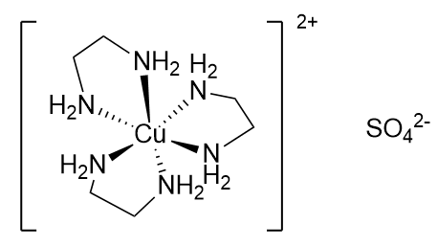
4. Potassium diaquabis(oxalate)manganate(III)
   1. 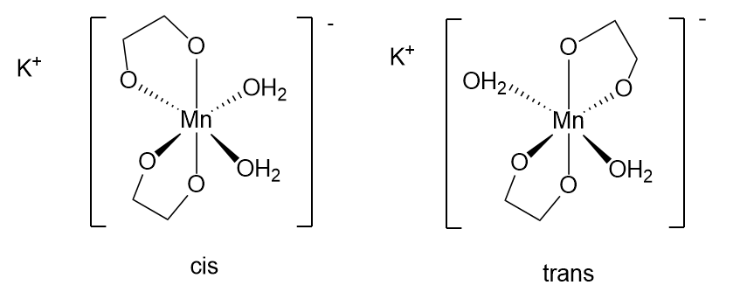
5. *Cis*-diaminebromochloroplatinum(II)

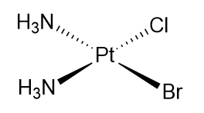

1. Diaquaiidodinitropalladium(IV), (did you mean Diaquadiiododinitropalladium(IV)?) all ligands *trans*

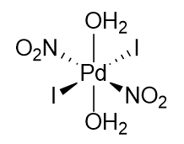

1. *u-oxo-bis[pentamminechromium(III)] ion*

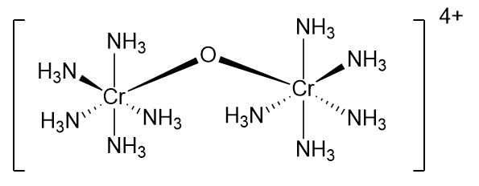

**Q3. Write formula of all constitutional isomers of CrCl3.6H2O**

Note: H2O can part of coordination ion complex or as hydrate.

1. [Cr(H2O)6]Cl3
2. [Cr(H2O)5Cl]Cl2 · H2O
3. [Cr(H2O)4Cl2]Cl · 2 H2O
4. [Cr(H2O)3Cl3] · 3 H2O

**Q4. Sketch all isomers of the following. Indicate clearly each pair of enantiomers. Label *them fac mer, cis or trans* if any.**

1. [Pt(NH3)3Cl3]

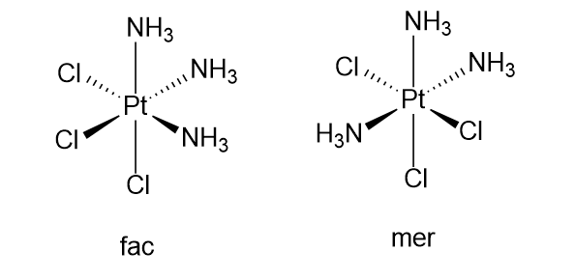

1. [Co(NH3)2(H2O)2Cl2]

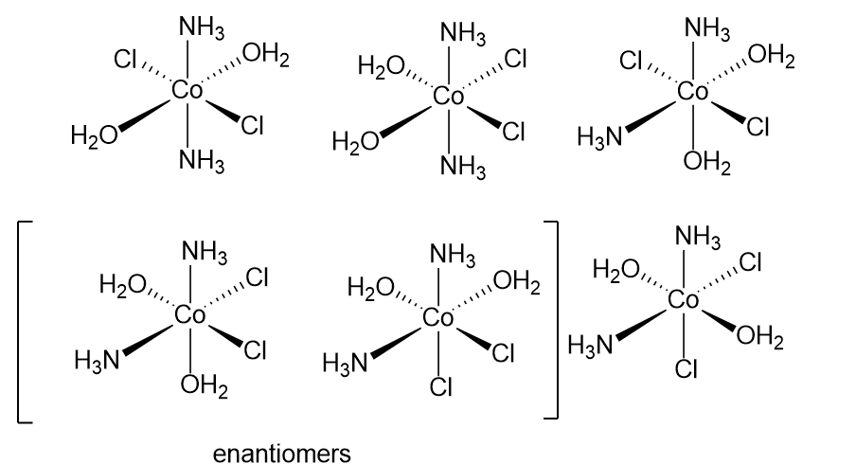

1. M(AB)3, in which AB is a bidentate unsymmetrical ligand.

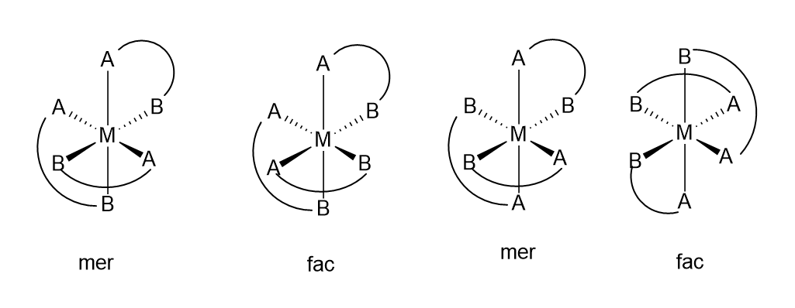

**Q5.** The (2-aminoethyl)phosphine ligand has the structure below, it often acts as a bidentate ligand toward transition metals.When this ligand forms monodentate complexes with palladium, it bonds through its phosphorous atom rather than its nitrogen. Suggest an explanation.

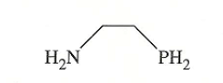

It bonds through the phosphorus atom because the phosphorus atom is larger than the nitrogen atom, and thus has more electrons to contribute than nitrogen. Thus, when bonding, there is a greater chance for palladium to interact with the electrons on the phosphorus atom than the nitrogen.

**Q6.(a) Predict the number of unpaired electrons for each of the following using Crystal Field Theory (b) Label as high spin or low spin and diamagnetic or paramagentic**

1. A tetrahedral d6 ion

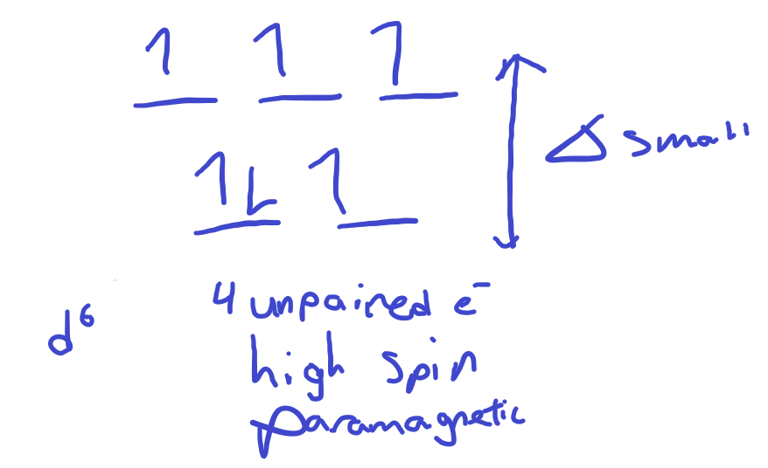

1. [Co(H2O)6]2+

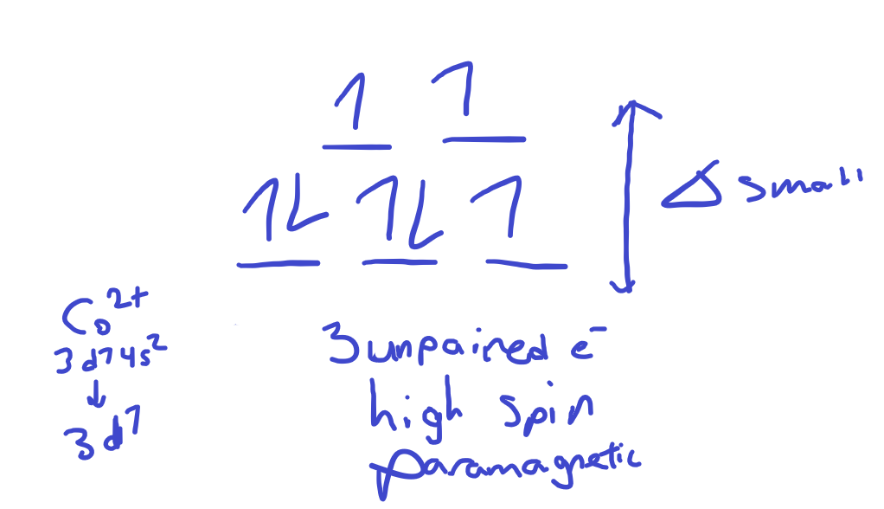

1. [Fe(CN)6]3-

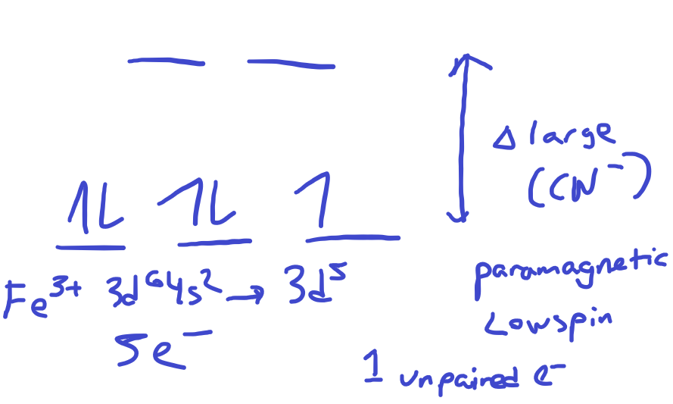

1. [Mn(CN)4]1-

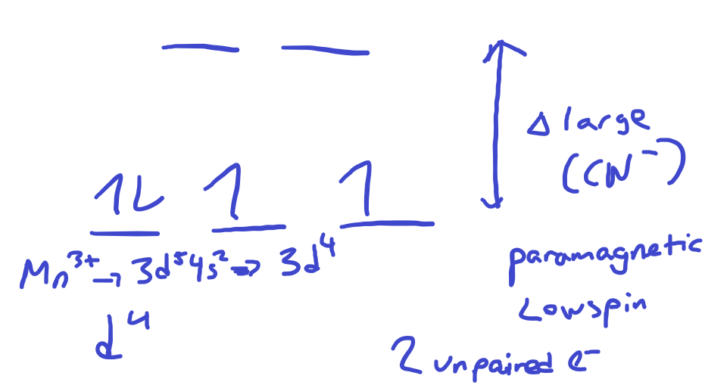

1. [FeBr4]2-

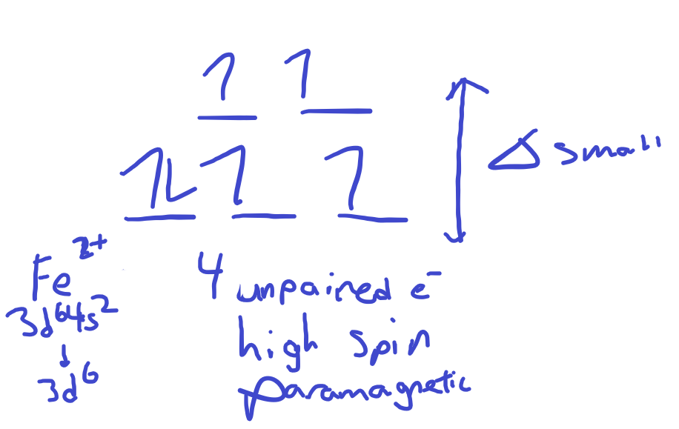

**Q7. Identify the most likely transition metal M**

K3[M(CN)6], in which M is a first-row transition metal and the complex has three unpaired electrons

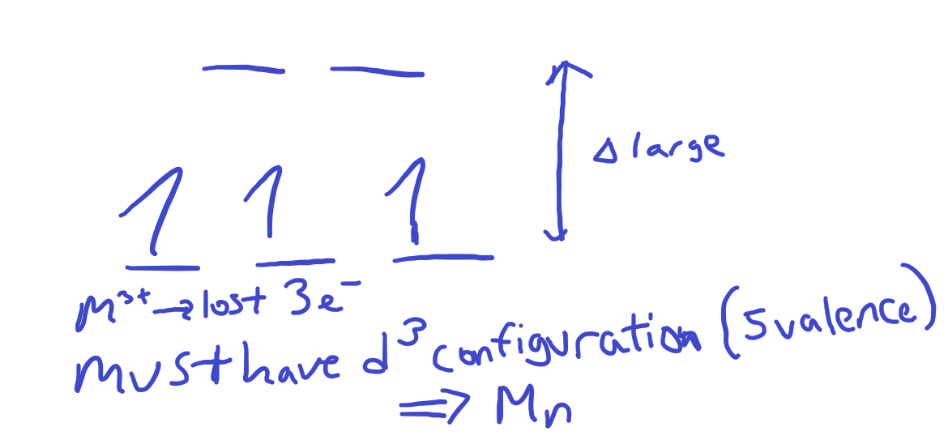

**Q8. (a)** The complex ion, [Ni(NH3)6]2+, has a maximum absorption near 580 nm. Calculate the crystal field splitting energy (in kJ/mol) for this ion. (**b)** What is most likely the color of this compound?

A) 114 kJ/mol

B) 292 kJ/mol

C) 343 kJ/mol

**D) 206 kJ/mol**

E) 485 kJ/mol

$$E=hv=\frac{hc}{λ}=\frac{\left(6.626*{10}^{-34} J∙s\right)*(3.00*{10}^{8}\frac{m}{s})}{\left(580 nm\right)*(1*{10}^{-9}\frac{m}{nm} )}=3.427*{10}^{-19} J*\frac{6.02*{10}^{23} photons }{1 mol}*\frac{1 kJ}{1000 J}=206 kJ/mol$$

This compound is most likely blueish-purple, as it absorbs between orange and yellow.